Name:Dhanashree Anil Jadhav
Department:Cybersecurity
Windows Registry Change Monitoring System
Introduction:
The Windows Registry is a centralized database used by Microsoft Windows to store system settings, application configurations, startup programs, and security-related information.
Cyber attackers and malware frequently modify registry keys to establish persistence, disable security features, or execute malicious programs automatically during system startup.
This project provides a monitoring solution that continuously observes registry changes and generates alerts whenever suspicious activities are detected.
Abstract:
The Windows Registry Change Monitoring System is a security monitoring tool developed in Python to detect unauthorized modifications in critical Windows Registry locations. The system captures a baseline snapshot, continuously monitors registry entries, detects additions, deletions, and modifications, generates alerts, identifies suspicious autorun entries, and maintains integrity check logs for security analysis.
Objectives:
- Monitor critical Windows Registry keys.
- Detect registry changes in real time.
- Identify suspicious autorun programs.
- Generate malware-pattern alerts.
- Maintain integrity verification against a baseline.
- Produce logs and summary reports.

Software Requirements
- Windows 10/11
- Python 3.x
- Registry Editor (regedit)

Screenshots: code
Baseline:
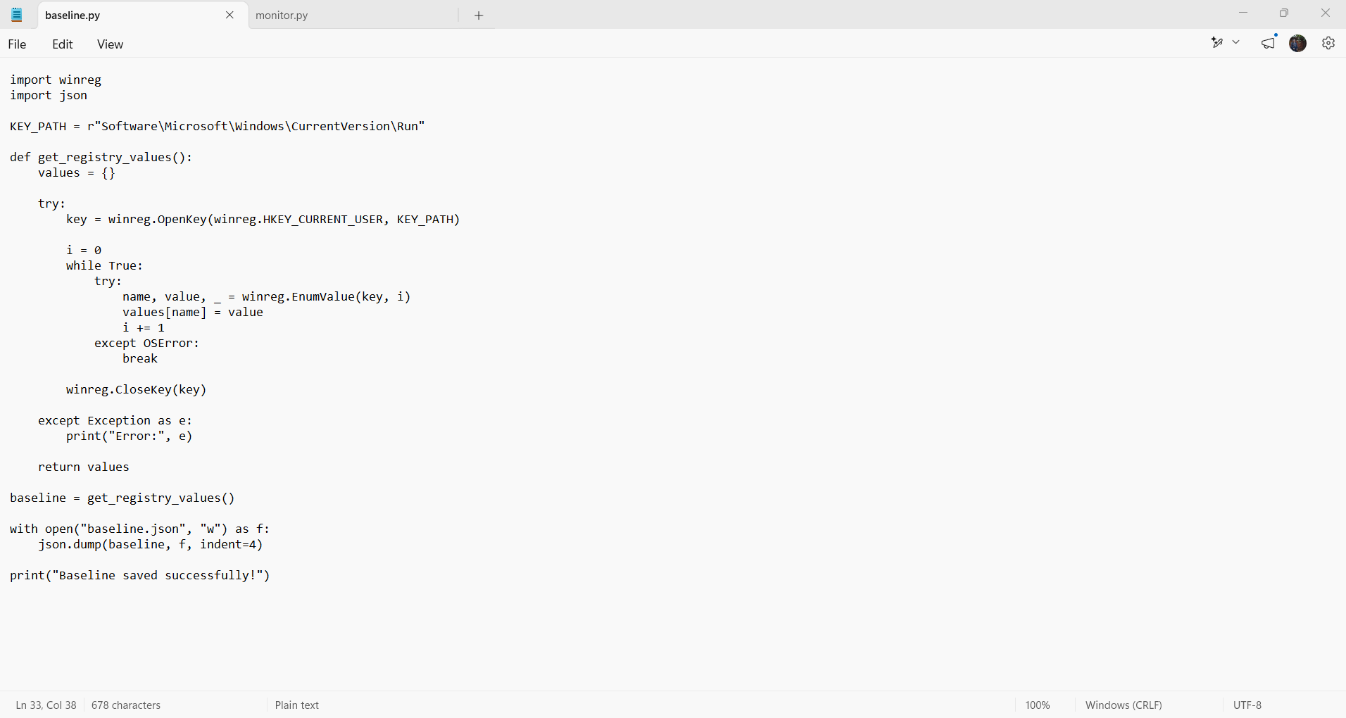
Monitor:
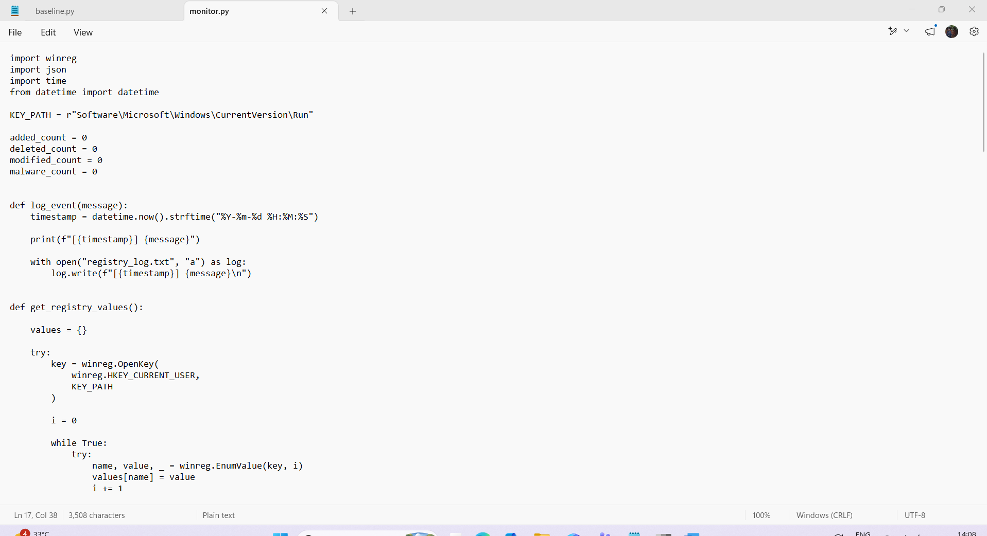
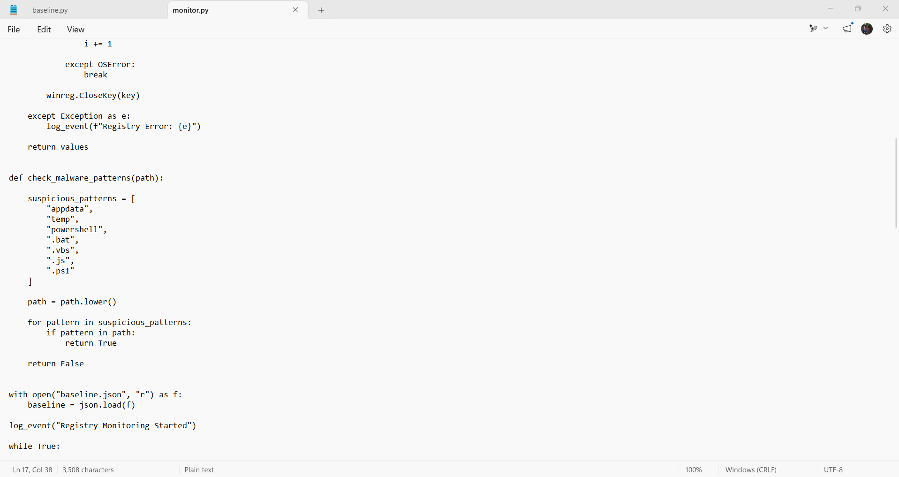
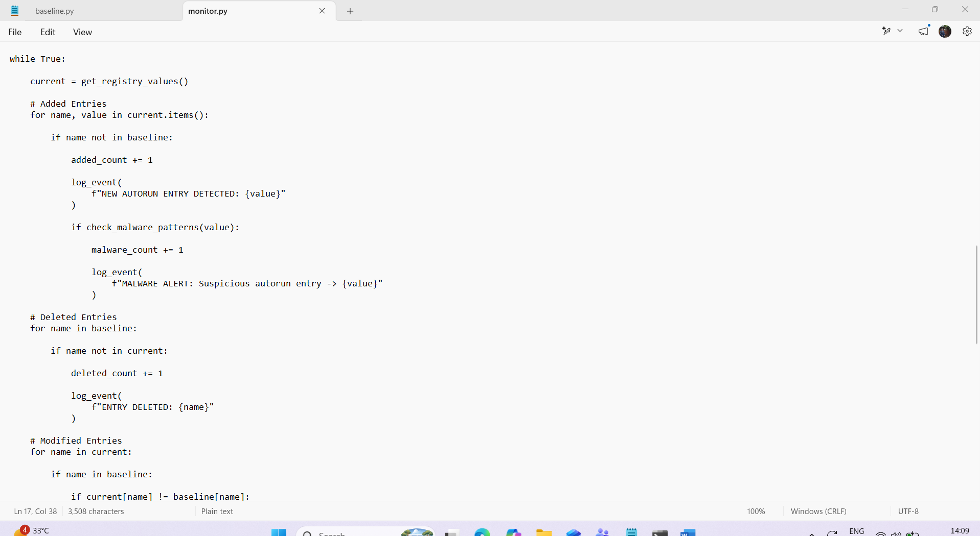
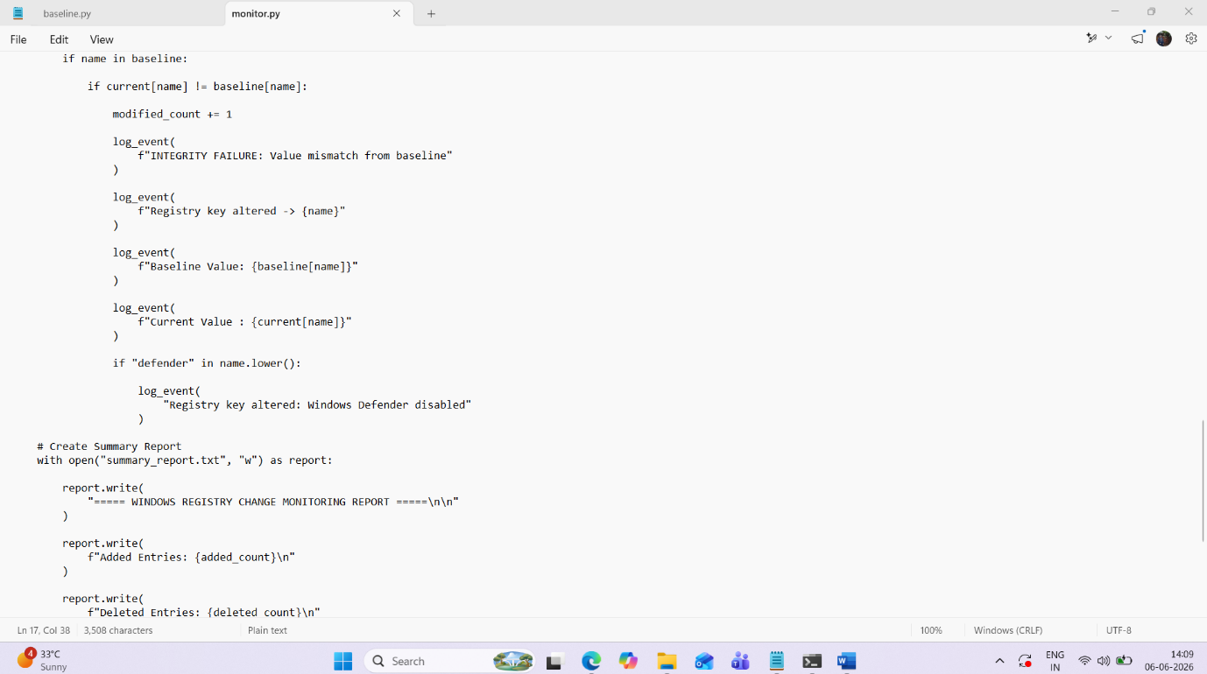
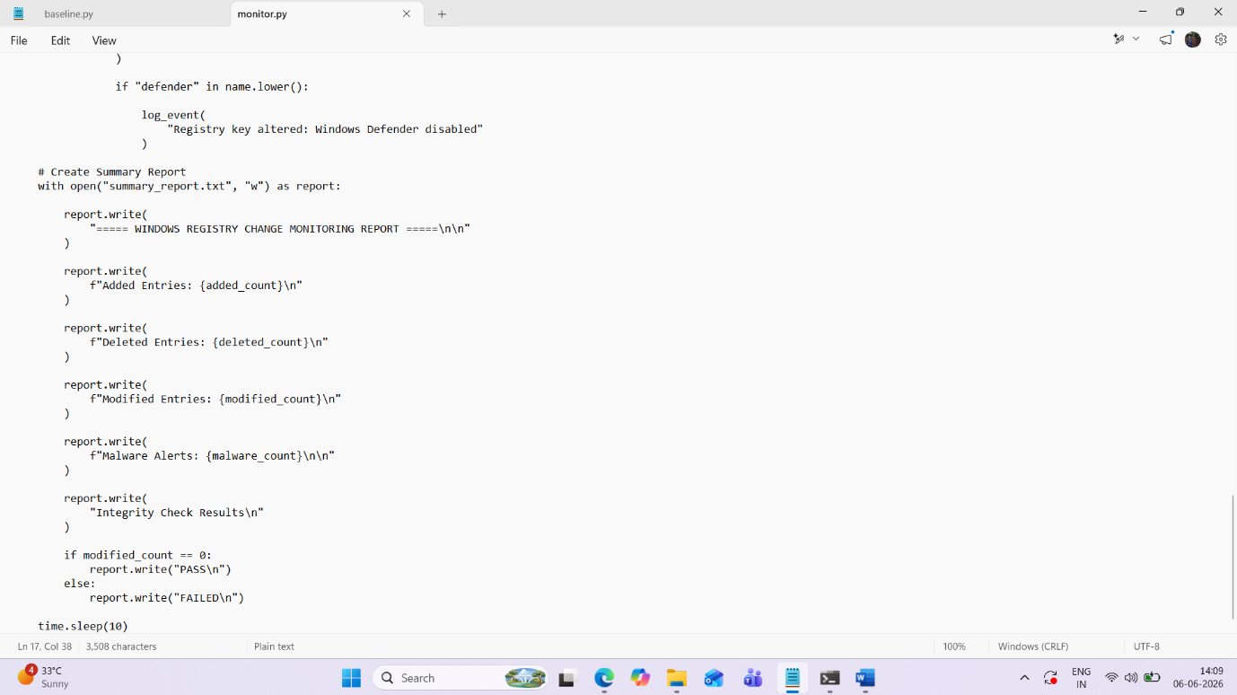
CMD:
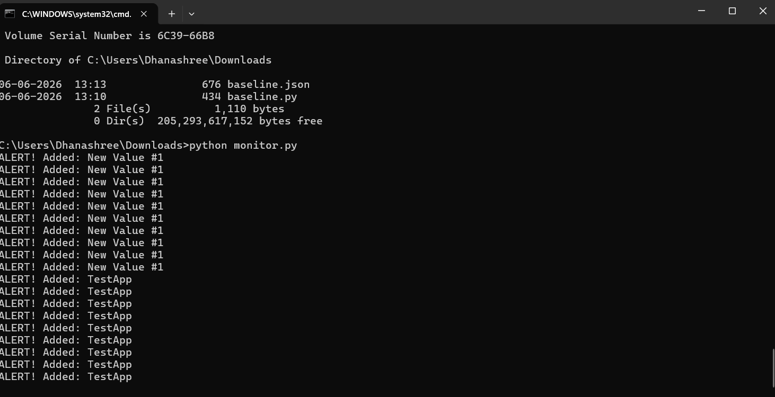
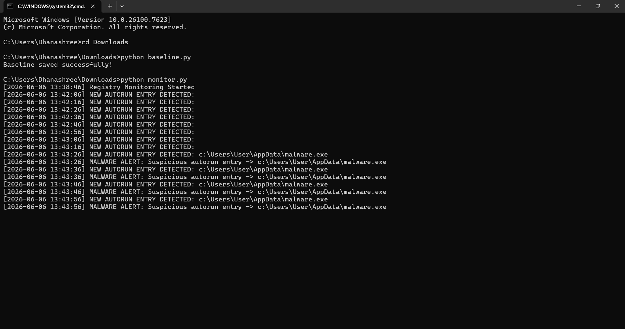
Registry:
HKEY_CURRENT_USER
└ Software
└ Microsoft
└ Windows
└ CurrentVersion
└ Run
Create a Test Entry
Right-click → New → String Value
Enter:
1.Name: TestApp
Value: C:\Temp\TestApp.exe
2.Name: MalwareTest
Double-click it and set:
Value:
C:\Users\User\AppData\malware.exe

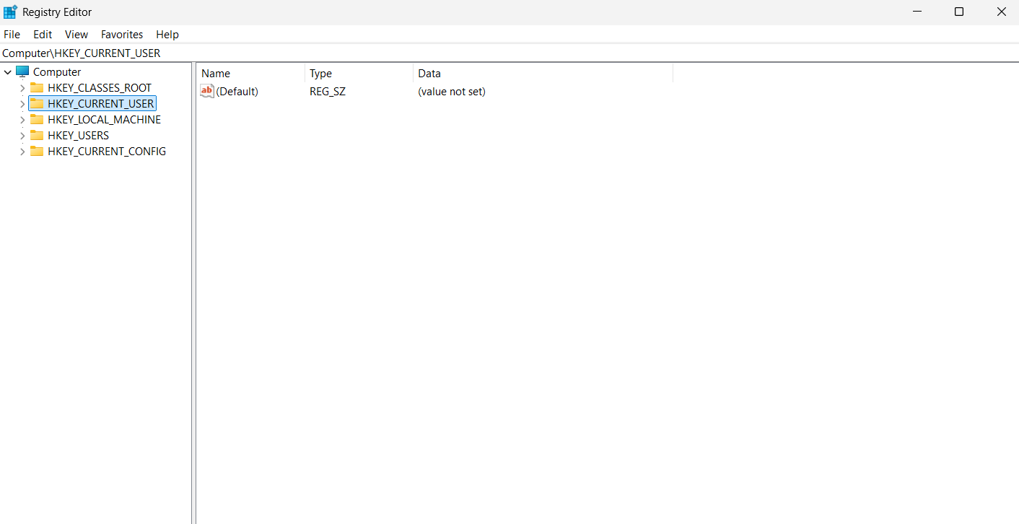
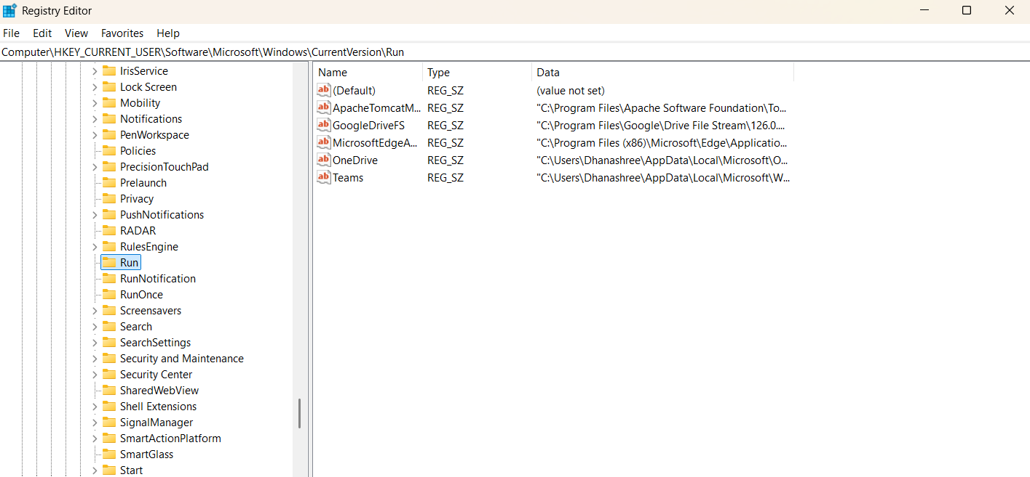
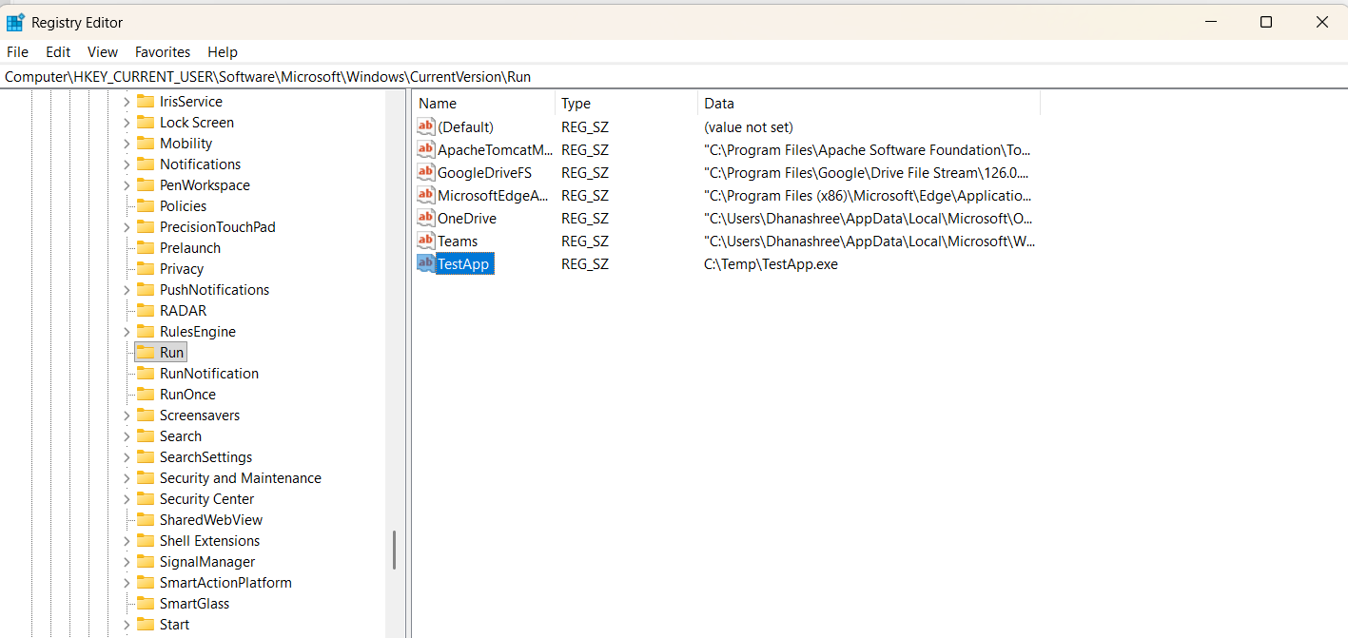

Flowchart:

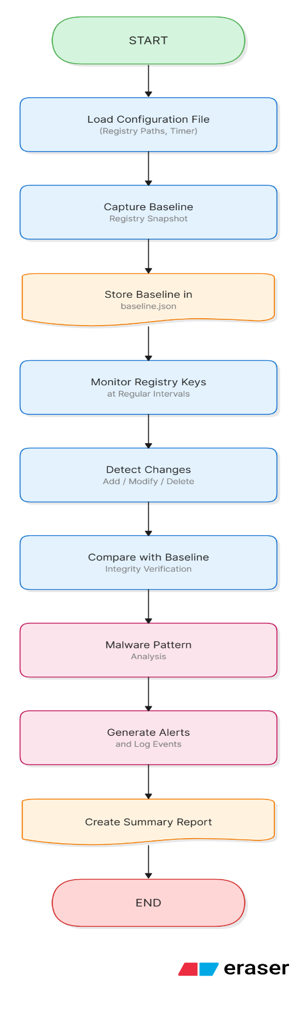

System Architecture Diagram:
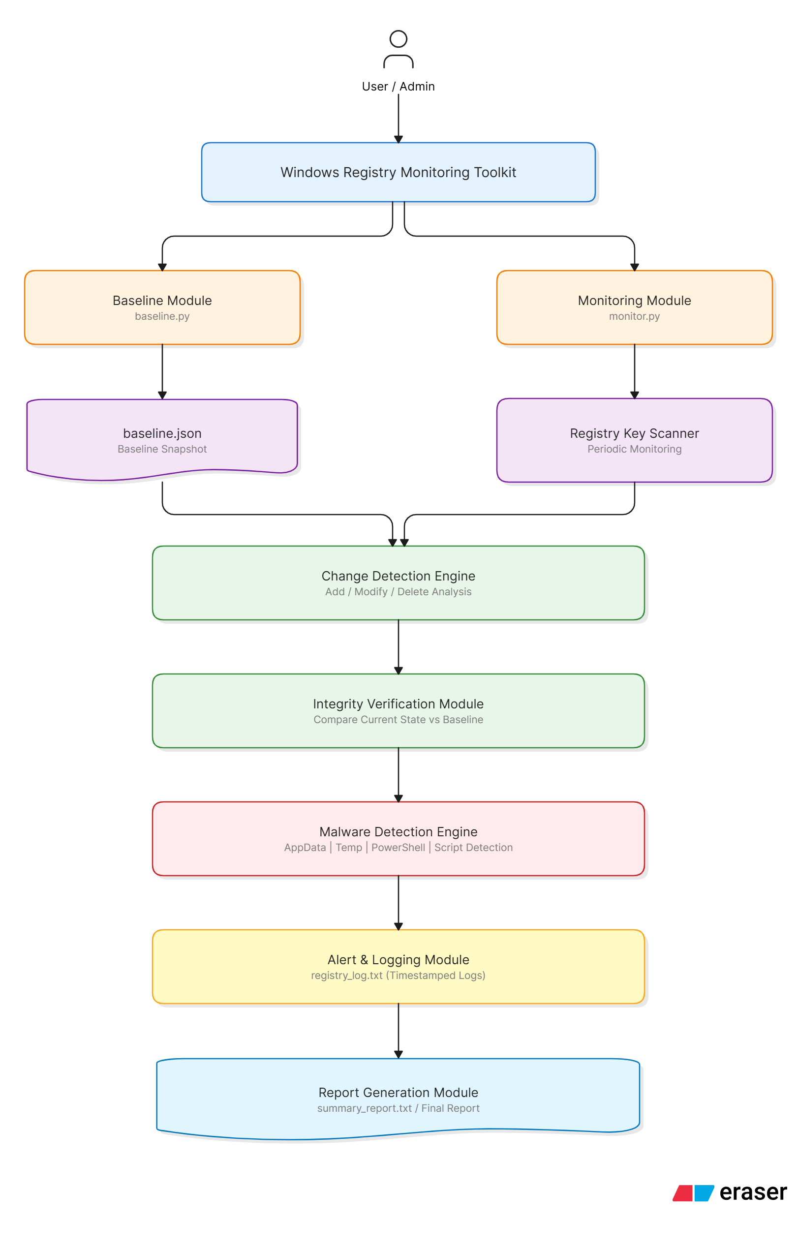
Results
The toolkit successfully:
- Monitored registry changes.
- Detected unauthorized modifications.
- Generated malware alerts.
- Performed integrity verification.
- Generated reports and logs.

Advantages
- Real-time monitoring.
- Easy implementation.
- Lightweight design.
- Useful for malware detection.
- Supports security auditing.

Limitations
- Currently monitors only selected registry keys.
- Uses periodic scanning instead of event-driven monitoring.
- Limited malware signature database.

Future Scope
- Real-time registry event monitoring.
- GUI-based dashboard.
- Email notifications.
- SIEM integration.
- Digital signature verification.
- Hash-based malware detection.
- Advanced threat intelligence integration.

Conclusion
The Windows Registry Change Monitoring System successfully detects unauthorized registry modifications and suspicious startup entries. The system provides integrity verification, malware-pattern detection, logging, and reporting capabilities that assist in identifying potential security threats and maintaining system integrity.

